Clever Sign In!
The purpose of this letter is to share information regarding how students will login to access Clever. We will be using a single sign on platform called Clever. This platform is designed to consolidate our various technology sites and applications all into one dashboard. Our goal is to simplify the navigation experience for students (and parents), and to promote independence.
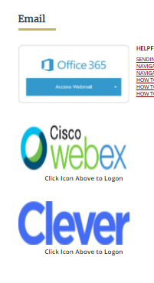
When students login, they will see a dashboard with tiles that they can click on to access Clever. Students will access Clever from the FPS homepage by clicking in the envelope icon in the upper right corner and then on the word Clever.

OR!

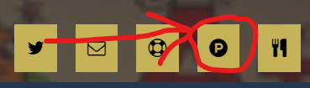

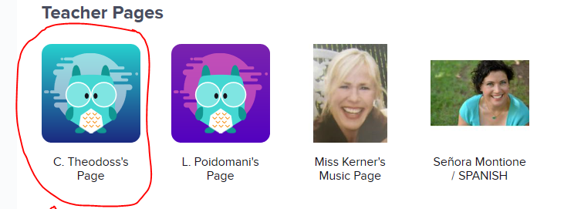
Once students are in Clever, they should click on “C. Lutz’s Page”.

Clever logins:
Example. John Smith, Username/Email = smithjoh29@student.foxboroughps.org
Password: 12345 (lunch number)

